**Task7-Gemini**

**Online Fonts and Their Integration into Websites**

**Online fonts** are font files hosted on external servers. They offer a convenient way to use a wide variety of fonts on your website without requiring visitors to download and install them locally. This ensures consistent typography across different devices and browsers.

**Using Google Fonts in HTML**

Google Fonts is a popular service that provides a vast library of free fonts. To use Google Fonts in your HTML document, follow these steps:

1. **Choose Fonts:** Visit the Google Fonts website (fonts.google.com) and select the fonts you want to use.
2. **Generate Code:** Click the "Select" button next to each font, then click the "View Code" button. This will generate a <link> tag that you need to include in your HTML document's <head> section.

**Example HTML code:**

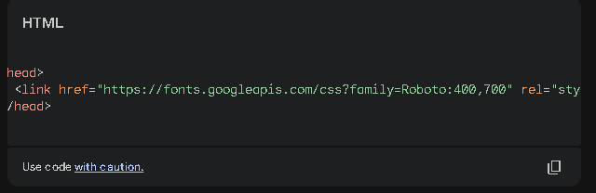

In this example, the Roboto font is loaded in both regular (400) and bold (700) weights.

1. **Apply Fonts:** Use CSS to apply the selected fonts to your website elements. For example:

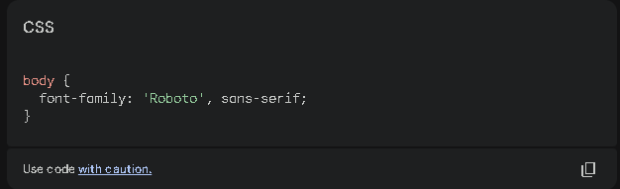

### What is a Favicon?

A **favicon** is a small icon that appears in the browser's tab or address bar. It helps users identify your website and can enhance its branding.

### Adding a Favicon to a Web Page

1. **Create a Favicon:** Design a small, square image (typically 16x16 or 32x32 pixels) in a format like PNG or ICO.
2. **Place the Favicon:** Save the image file in your website's root directory.
3. **Add HTML Code:** Include the following <link> tag in the <head> section of your HTML document:

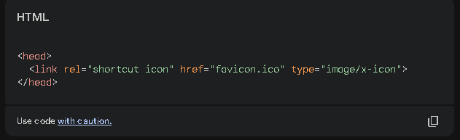

Replace favicon.ico with the actual filename of your favicon.

**Note:** For a more modern approach, you can also use the <link> tag with the rel="icon" attribute:

